**Action Against Vulnerability-**

**Crisis & Community Wellbeing Services**

**Contents:**

**Mental health Crisis Asylum/Refugees**

**Homeless/At Risk Sexual Health**

**Abuse Intervention Community Support/Inclusion**

**Addiction Support Mental Health Helplines**

**Mental health Crisis**

* **NHS Mental Health Initial Response 0800 013 0707**
* Mental Health Crisis Hopeline (under 35s) 0800 068 4141
* Wellbeing & mental health helpline 7-11pm weekdays, Sat-Sun 12noon until Midnight.0800 915 4640
* Blackburn Crisis team 01254 226074



**Homeless/At Risk**

* **Phoenix Hub Drop in Service– Clayton street BB2 2ED. Tues 9am – 12noon Wed 9am – 4pm Thurs 12-4pm Shower & Laundry Facilitates. Various Support –** housing, practical; clothes/food bank**,** mental health, drugs& alcohol support, benefits, Polish peer group.
* **Thomas Soup Kitchen Mon-Fri 1-2pm. Weekends: 12-12.30** (Near Farmfoods, off King ST) **St Anne's House, France Street, Blackburn**, Lancashire, BB2 1LX. 01254 677321 [beverley.suddick@thomasonline.org.uk](mailto:beverley.suddick@thomasonline.org.uk)
* **Salvation Army Hostel, Bramwell House, Heaton st Age 18+** 01254 677338
* **Nightsafe The Shelter Age 16-24.** 01254 503067 The Boulevard Centre, Cathedral Quarter, 45 Railway Road. Access 5pm – 10am.[**https://nightsafe.org/**](https://nightsafe.org/)

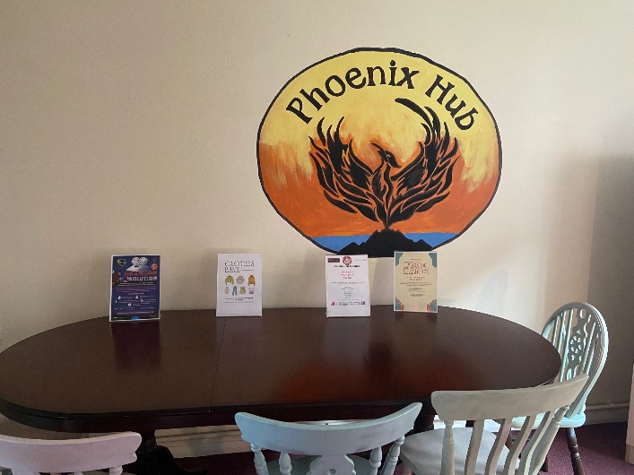 

* **Shelter Emergency Helpline** 0808 800 4444 . 0344 515 1831
* **Blackburn Council Housing Needs**, Town hall, king william st. 01254 585444/ 585585. Out of Hours contact 07739 454 978 <https://www.blackburn.gov.uk/housing/private-rented-list>
* **BWithUs Social Housing 0300 123 2200** <https://www.b-with-us.com/HouseholdRegistrationForm>

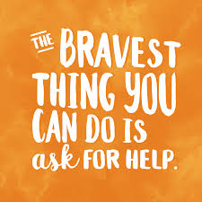

**Abuse Intervention**

* **Domestic Abuse, WISH Centre Blackburn 0300 561 0440** info@thewishcentre.org
* **RESPECT MENS Advice Line Freephone 0808 8010327** [**https://mensadviceline.org.uk/**](https://mensadviceline.org.uk/)
* **ManKind Helpline 01823 334 244** [**https://mankind.org.uk/**](https://mankind.org.uk/)
* **Refuge For Women & Children, Domestic Abuse 0808 2000 247**[**https://refuge.org.uk/**](https://refuge.org.uk/)
* Unseen UK Slavery & Exploitation helpline 08000 121 700 <https://www.unseenuk.org/>
* Forced Labour, Human Trafficking, SA Referral helpline 0800 808 3733 <https://www.salvationarmy.org.uk/modern-slavery/supporting-survivors>



* **Social Services Adult Safeguarding 01254 585 949**
* **Childrens Social services (Under 18) 01254 666400**
* NCPCC Report Current Or Historical Abuse 0808 800 5000 <https://www.nspcc.org.uk/>
* Trust house (Preston) Sexual Abuse Survivor Therapy 017728 25288 <https://trusthouselancs.org/>
* RSPCA Animal Protection 01254 23118 <https://www.rspca.org.uk/utilities/contactus/reportcruelty>

**101 Police None Emergency** [**https://doitonline.lancashire.police.uk**](https://doitonline.lancashire.police.uk/)

**111 NHS Medical none emergency** [**https://111.nhs.uk/**](https://111.nhs.uk/)

**Addiction Services/Meetings**

* **SPARK BWD Substance Misuse,** ST Johns Court, Ainsworth ST. 01254 495014 Email: BWD@calico.org.uk <https://sparkbwd.org.uk/>
* **For young people and families**, please contact 0161 723 3880 or email info@earlybreak.co.uk
* **Cocaine Anonymous 0800 612 0225.** Wednesdays 19:00-21:00 at Community Hub CVS, 3 Railway road. EMAIL: Helpine@cauk.org.uk

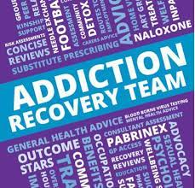

* **Alcoholics Anonymous 01254 583957** Sacred Heart Church, Preston New Rd, Billinge Ave, Blackburn. Sundays, Time: 19.30 - 21:00 **Call our National Helpline 0800 9177 650** **help@aamail.org** [**https://www.alcoholics-anonymous.org.uk/AA-Meetings/Find-a-Meeting/Blackburn**](https://www.alcoholics-anonymous.org.uk/AA-Meetings/Find-a-Meeting/Blackburn)
* **Alcoholics Anonymous ‘Design for Living’ Mill Hill** Community Centre, New Chapel ST Thursdays 19.30 - 21:00.
* **Narcotics Anonymous** National Helpline on 0300 999 1212 Meetings: Mondays 19:00 - 20:30 Community hub CVS 35 railway road <https://meetings.ukna.org/meeting/blackburn-recovery-group>
* **National Gambling Helpline 0808 8020 133** and also offers face-to-face counselling. The helpline is free and open 24 hours.
* **Meetings Gambling Anonymous** 19:00 - 21:30 Wednesdays. Address: Salvation Army, Vicar Street, Blackburn, BB1 5BE *The venue entrance is opposite Morrisons. The meeting room is upstairs. Phone: 07974 668 999 Email: [ark-one@hotmail.com](mailto:ark-one@hotmail.com)

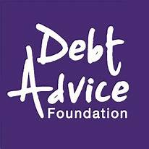

**Financial/Debt Support**

* **Debt Advice Foundation 0800 0434050** [**https://www.debtadvicefoundation.org/**](https://www.debtadvicefoundation.org/)
* **National Debt Helpline 0808 808 4000** [www.nationaldebtline.org/](http://www.nationaldebtline.org/)
* **Universal Credit 0800 055 6688.**
* **PIP Contact 0800 121 4433**   
  [www.moneyadviceservice.org.uk/en](http://www.moneyadviceservice.org.uk/en)

[www.turn2us.org.uk/About-Us](http://www.turn2us.org.uk/About-Us)

**Asylum & Refugees Support**

* **ARC Refugee & Asylum Seekers Support Wesley Hall, Fielden st, BB2 1LQ**   
  01254 690282, 07724 045265/ 07359 025471.[**Info@arcblackburn.org.uk**](mailto:Info@arcblackburn.org.uk)

[**https://arcblackburn.org.uk/**](https://arcblackburn.org.uk/)

* **DARE Darwen Asylum Refugee,** a drop-in service **Wednesdays from 9 am to 1. 30pm** in the Central United Reformed Church on Duckworth Street, Darwen BB3 1AT. **01254 774511**
* **Call Migrant Help UK** if you’re an adult asylum seeker or the dependant of an adult asylum seeker. **0808 801 0503** [**https://www.gov.uk/asylum-helplines**](https://www.gov.uk/asylum-helplines)
* **Call Children’s Panel if you’re a child in the UK on your own and applying for asylum. 020 7346 1134**

**Sexual Health Service**

**Brook Sexual Health Clinic** 54 Darwen st. 01254 268700

<https://www.sexualhealthblackburn.co.uk/sti-home-testing/>



**Community Support & Inclusion**

* **Care Network Hub –Sign Posting to Support Services**, town hall St, opposite the library. **01254 507225** [**https://www.carenetwork.org.uk/**](https://www.carenetwork.org.uk/) Connecting individuals to services, Community, Information, Wellbeing. Monday- Friday 9am – 5pm (Thursdays 3.30pm close)
* **Creative Social Inclusion.** A not-for-profit organisation promoting the independence, inclusion and wellbeing of people with care and support needs. <https://www.creativefootball.co.uk/contact-us>

Based at 3G Offices, Witton Park, Preston Old Road, Blackburn BB2 2TD **Contact 01254 661 501  Hello@creativefootball.co.uk**

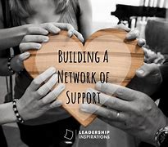

* **Shad Chefs Community Groups- Womens Hub: Mondays 7-9pm** The Hub, Shadsworth, Rothesay road, Blackburn, BB1 2ES.
* **Shad** **Mens** **Hub: Thursdays 7-9pm** St Oswalds Community Hall, Fecitt Brow, BB1 2AT. [**https://www.facebook.com/ShadChefs**](https://www.facebook.com/ShadChefs)
* **Darwen Mans Hub - Talk Ourselves Well** Every Thursday 6-8pm Meet at Whitehall Park Darwen. 07498 300556 [talkourselveswell@gmail.com](mailto:talkourselveswell@gmail.com)[**https://www.facebook.com/TALKOurselvesWELL**](https://www.facebook.com/TALKOurselvesWELL)

* **Lancashire Women 0300 330 1354**. Support, Counselling, Raising Aspirations <https://lancashirewomen.org/> Email: [talktous@lancashirewomen.org](mailto:talktous@lancashirewomen.org)
* **Red Rose Recovery – Roots Community ; Activities for wellbeing** [**https://redroserecovery.org.uk/activities-and-events/**](https://redroserecovery.org.uk/activities-and-events/) **Contact Rolonde Bradshaw, Community Engager 07572 610 530 | Rolonde.Bradshaw@RedRoseRecovery.org.uk**
* **Witton Park Greenhouse Project.** **Volunteering opportunities for wellbeing. Tuesdays & Thursdays Open Drop In. 01772 872 007.** <https://www.lancswt.org.uk/our-work/projects/myplace> Email: [info@lancswt.org.uk](mailto:info@lwt.org.uk) [myplace@lancswt.org.uk](mailto:myplace@lwt.org.uk)

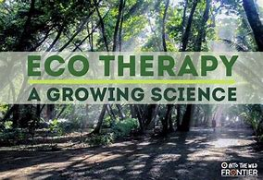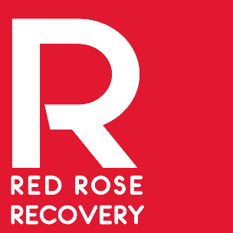

* **BWD Free Adult Learning/Well being courses.** 01254 581175 Bank top neighbourhood learning centre, Arthur way OR Audley Learning Centre, 54 Audley Range. <https://www.bwdlearning.org/findacourse>
* **Adult English, Maths, ICT** at Blackburn College, Fielden street 01254 292929 [thehub@blackburn.ac.uk](mailto:thehub@blackburn.ac.uk) <https://blackburn.ac.uk/find-a-course/english-and-maths/english/skills-for-life-english-maths-or-ict>



* **Citizens Advice Lancashire 0808 278 7880.** [**https://citizensadvicelancashirewest.org.uk/contact-us/**](https://citizensadvicelancashirewest.org.uk/contact-us/)Housing, Employment, Debt, Benefits, Immigration. Free, confidential, impartial and independent advice and information.
* **Blackburn Library , Town Hall street. 01254 661221 Open Monday 10:00am – 19:00pm, Tuesday to Friday 10:00am – 17:00pm. Saturday 10am-16:00pm.** Library@blackburn.gov.uk Computers offering free internet, free Wi Fi, information services - transport, health information, community news, printing, scanning, photocopying facilities, accessible toilet.

**Mental health HELPINES**

* **SANEline.** If you're experiencing a mental health problem or supporting someone else, you can call [SANEline](http://www.sane.org.uk/what_we_do/support/helpline) on [0300 304 7000](tel:+44-03003047000) (4.30pm–10.30pm every day).
* **National Suicide Prevention Helpline UK.** Offers a supportive listening service to anyone with thoughts of suicide. You can call the [National Suicide Prevention Helpline UK](https://www.spuk.org.uk/national-suicide-prevention-helpline-uk/) on [0800 689 5652](tel:+44-08006895652) (6pm to midnight every day).
* **Campaign Against Living Miserably (CALM).** You can call the [CALM](https://www.thecalmzone.net/) on [0800 58 58 58](tel:+44-0800585858) (5pm–midnight every day) if you are struggling and need to talk. Or if you prefer not to speak on the phone, you could try the [CALM webchat service](https://www.thecalmzone.net/help/webchat/).



* **Shout. If you would prefer not to talk** but want some mental health support, you could text SHOUT to 85258. [Shout](https://giveusashout.org/) offers a confidential 24/7 text service providing support if you are in crisis and need immediate help.
* **The Mix. If you're under 25**, you can call The Mix on [0808 808 4994](tel:+44-08088084994) (3pm–midnight every day), request support by email [using this form on The Mix website](https://www.themix.org.uk/get-support/speak-to-our-team/email-us) or [use their crisis text messenger service](https://www.themix.org.uk/get-support/speak-to-our-team/crisis-messenger).
* **Papyrus HOPELINEUK. If you're under 35** and struggling with suicidal feelings, or concerned about a young person who might be struggling, you can call [Papyrus HOPELINEUK](https://www.papyrus-uk.org/) on [0800 068 4141](tel:+44-08000684141) (weekdays 10am-10pm, weekends 2pm-10pm and bank holidays 2pm–10pm), email [pat@papyrus-uk.org](mailto:pat@papyrus-uk.org) or text 07786 209 697.

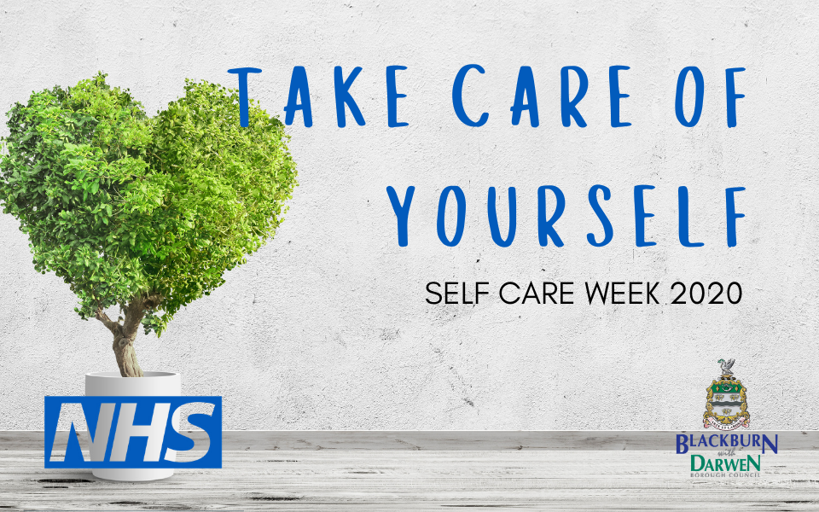

[**Www.Mind.org.uk**](http://www.mind.org.uk/)

[**https://www.lancashiremind.org.uk/**](https://www.lancashiremind.org.uk/)

[**https://www.papyrus-uk.org/places-to-turn-for-help/**](https://www.papyrus-uk.org/places-to-turn-for-help/)

**Resources/Publisher Contact:** [**GoldentrustUK@outlook.com**](mailto:GoldentrustUK@outlook.com)[**www.goldentrustuk.org/**](https://www.goldentrustuk.org/)

